# Copy from JSON Format to Profisee REST API

This article describes a solution template that you can use to copy records from Azure Data Lake Storage Gen2 JSON storage to Profisee REST API.

## About this solution template

This template copies records from ADLS Gen2 in JSON format to Profisee via the REST API. The template is designed to work with a folder structure consisting of a subfolder for each entity within the input container. The file name must have the .json extension.

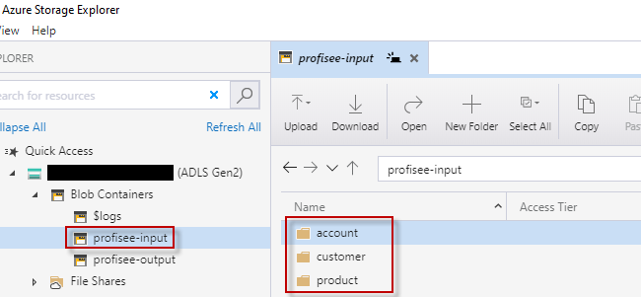

**How to use this solution template**

1. Go to the **Copy from JSON to Profisee REST API** template.

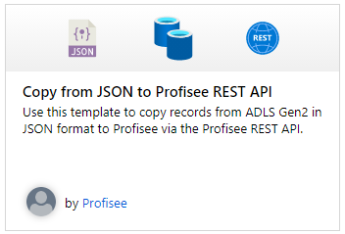

1. Create a **New** or use an existing connection to the BlobStorageGen2 data store that you are copying data from.
2. Create a **New** or use an existing connection to the sink Profisee REST API.

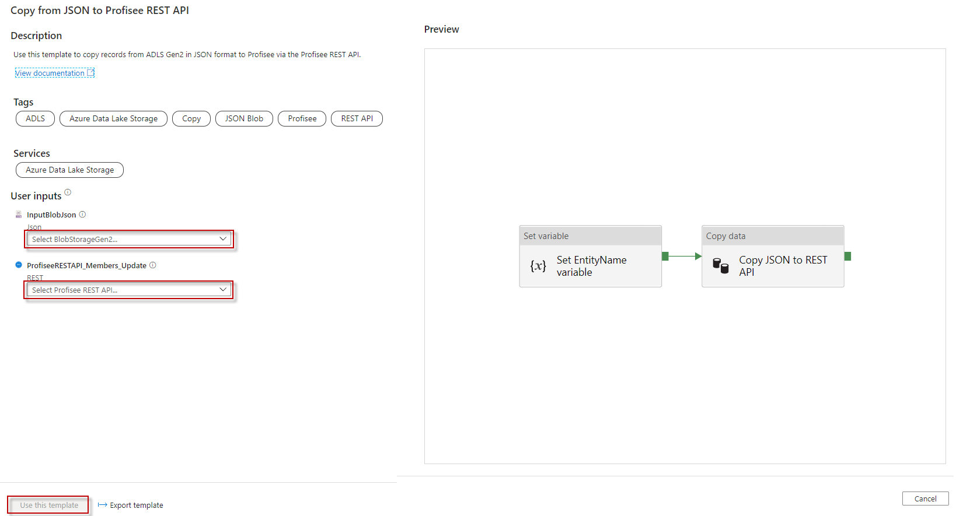

* 1. Follow these steps if you need to create a new REST linked service.
  2. Select “+ New" from the **REST** dropdown list.

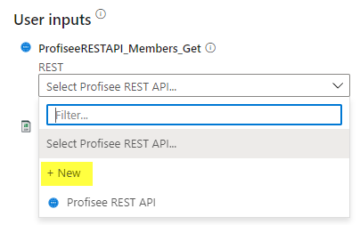

* 1. Enter the following information for the REST linked service.
     1. Name: Enter a unique name within your ADF.
     2. Description: Enter an optional description.
     3. Integration runtime: You can select the auto resolve option or create a custom integration runtime. Some linked services that ADF integrates with requires the ADF integration runtime be in the same region as the service. In this case you will need to create a custom integration runtime in the same region as that linked service.
     4. Base URL: enter the base URL to your deployed Profisee REST API.
     5. Authentication type: select **Anonymous**

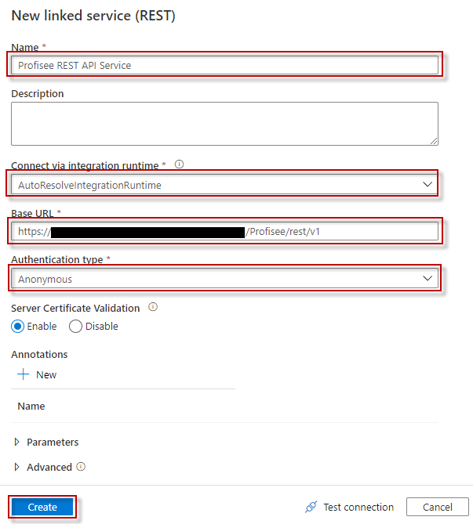

1. Select **Use this template**.
2. You will see a pipeline created as shown in the following example:

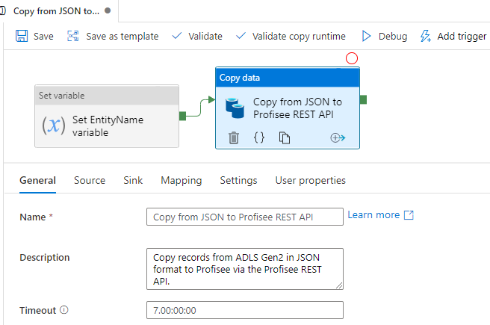

You should also see the following template validation output.

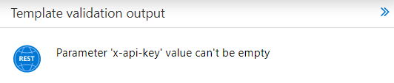

There is one item needed for the pipeline.

* 1. **x-api-key:** The Profisee API key, which is the Client Id for the user account you are using to connect to the Profisee API. This is entered in the Source tab. **Note:** According to Microsoft, this will be an option in the Linked Service dialog when creating the REST API connection. We will update this documentation at that time.

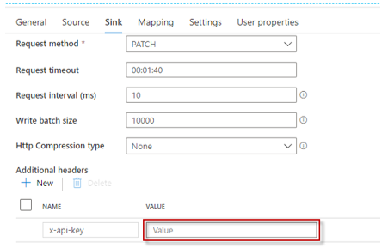

1. The pipeline has the following Parameters and Variables
   1. The FileFolder within the InputBlobJson container.
   2. The FileName of the file containing the records in JSON format which the Profisee REST Update API expects. Must end in .json file extension.

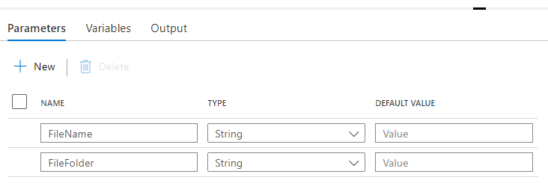

* 1. The EntityName.

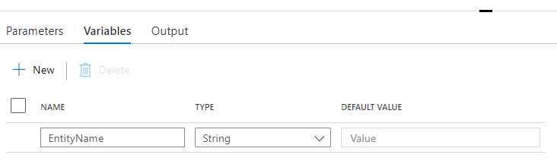

* 1. The **Set EntityName variable** activity will set the **EntityName** variable using the FileFolder path. It uses a container name of **profisee-input** however you can use a different name. For example, a FileFolder path of **profisee-input/product** will result in an EntityName of **product**.

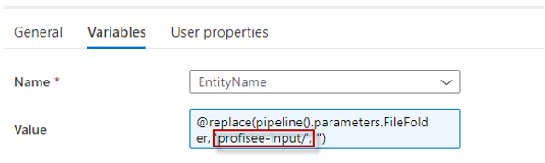

1. The Source dataset properties are set from the two pipeline parameters.

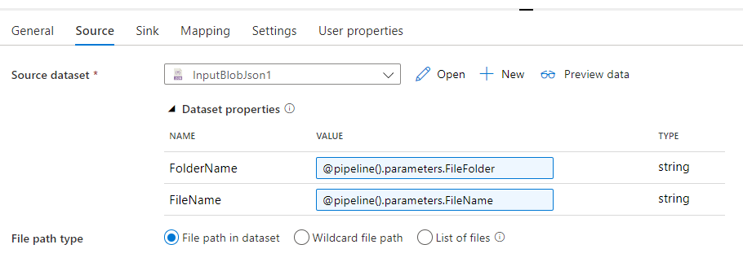

1. The Sink dataset properties are set from the EntityName variable and the isUpsert is set to true. You can change it to false if you wish to perform an Update instead of an Upsert. The **Request method** must be set to **PATCH**.

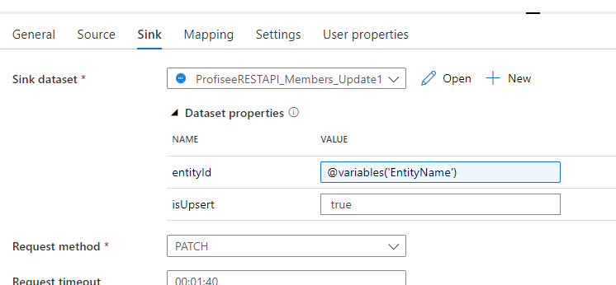

1. You can trigger the pipeline manually, but you can also create an Event trigger to trigger the pipeline to run any time a new file is uploaded to the container.
   1. Set up your trigger pointing to your input container. Enter the **Container name** in this format **/<container name>/**. For example: **/profisee-input/**. Click **Continue** when done. Note: the Container name must match the input container name entered in the **Set EntityName variable** activity above.

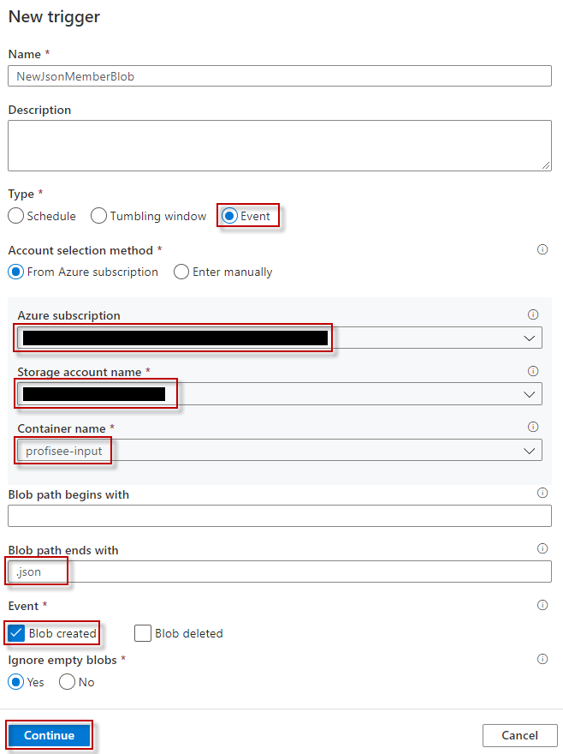

* 1. Click **Continue** on the **Data preview** page.

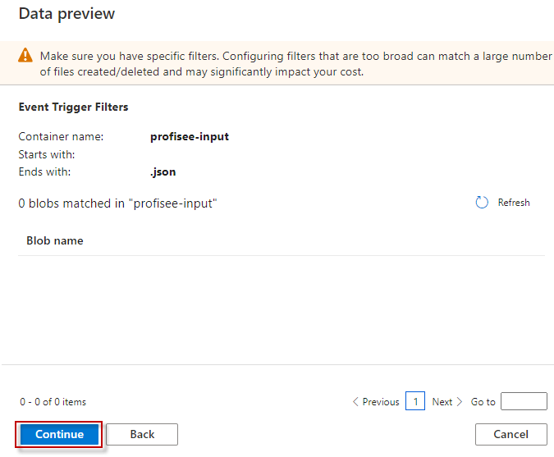

* 1. Enter the following **Trigger Run Parameters**

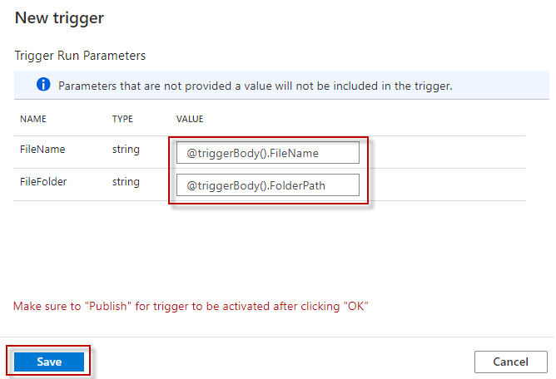

1. Once you are finished with all your changes, click Publish All.



1. If you added an event trigger, upload a file to an entity folder within your input container. The file must contain the members in JSON format. An example is shown below.

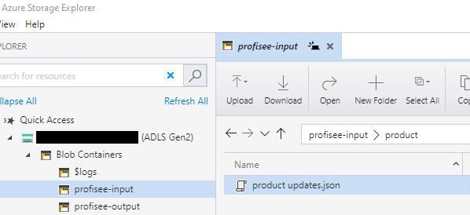

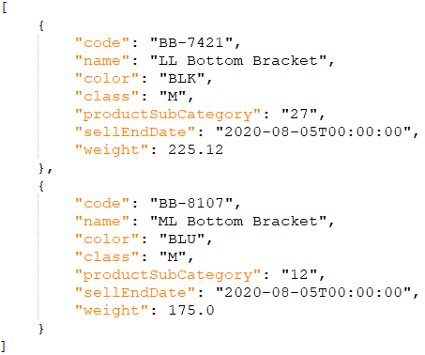

1. Select **Monitor** tab in the left navigation panel and wait for about 20 seconds. Click **Refresh** to get the updated run status.
2. When the pipeline run completes successfully, you would see results like the following example. Notice the pipeline was triggered by the event trigger.

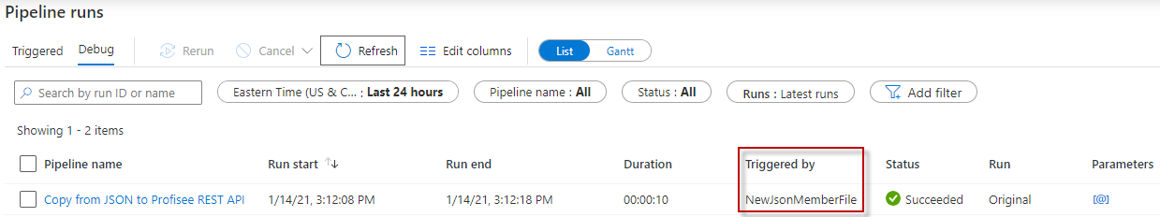

## Sink parameters

You can customize the operation by changing **isUpsert** to false. When set to false it performs an Update instead of an Upsert (coming in a future release).

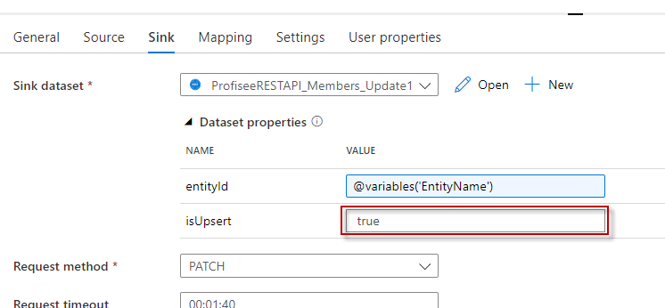

## Next steps

* [Introduction to Azure Data Factory](https://github.com/MicrosoftDocs/azure-docs/blob/master/articles/data-factory/introduction.md)